Staying Healthy As A Senior During The COVID 19 Pandemic
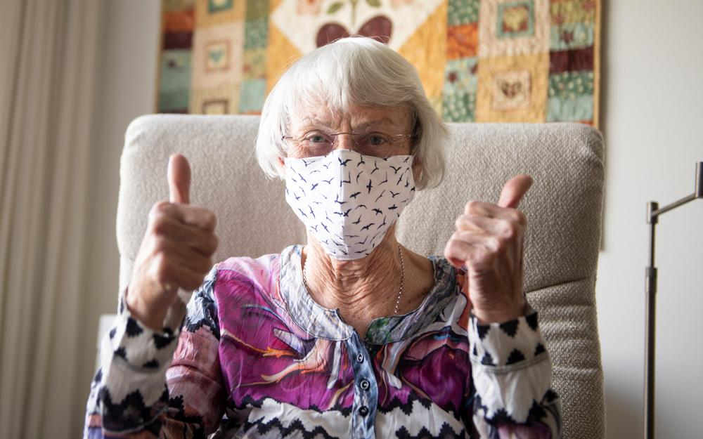

The increased need for COVID-19 monitoring, assessment, and diagnosis has rendered it more challenging for healthcare organisations to reach out to older adults who need other forms of care. However, many have found ways to provide incentives for older adults to participate in a range of positive activities inside their homes or neighborhoods and to communicate with supportive tools and programmes.

Here are some ideas on how senior citizens can stay healthy and active in these trying times.

Plan Your Day

Prepare yourself for each day. Although the days can feel like an infinite blur, keep up with daily tasks such as getting out of bed, getting ready, and participating in small activities will keep the day interesting. Spending time preparing for online courses, calling friends, solving puzzles, reading, gardening or doing home maintenance will make the days meaningful.

Engage in Physical Activity
It is normal for older people to be worried about their health when they plan to exercise at home, but evidence has shown that the dangers of exercising at home are no greater than community workouts.

Continuing exercise is critical for improving your immune systems and preserving your health. When it comes to physical activity, professionals suggest participating in moderate-intensity physical exercise for over 150 minutes a week. Before engaging in some form of workout though, you ought to consult with your doctor to be sure that the exercises you intend are healthy and suitable.

Start slowly with low-intensity activities like walking or low-impact workouts for shorter periods of time if you are not used to physical activity, and build up progressively over time. Choose the right activity to reduce the risk of injury; the exercise intensity should correspond to your fitness and health status.

Remember, long physical inactivity and sedentary conduct (sitting) can increase the risk of getting sick, raise cardiovascular risk profile, reduce physical and cognitive ability as well as affect the mental wellbeing in patients with rheumatic diseases, contributing to reduced quality of life. Sustaining more acceptable levels of physical activity can tend to reduce these adverse effects.

Stay Connected
Given the current COVID-19 pandemic and social isolation requirement, there are strategies to help older adults remain linked. Use technology to keep in touch, particularly video communication; as seeing the expressions on someone's face will help to enhance communication.
Using twitter, phone calls, emails, and other interactive resources to check in with your mates, relatives, and neighbors daily are some of the ways to communicate comfortably. Online learning and online networking may also aid in mental interaction and stimulation.

Take Care of Your Mental Health
Seniors in segregated housing environments are most likely to experience underlying mental health conditions. It raises the likelihood of impaired memory performance, diabetes, cardiac failure, and stroke. It also carries with it a greater chance of developing disorders such as common cold and suffering from more serious ailments.
According to a 2015 report, even among younger people, depression is about as detrimental to safety as consuming 15 cigarettes a day. Another report, published in 2013, found that older solitary or isolated men and women had a significantly higher risk of dying.
Unfortunately, because seniors are more prone to suffer significant symptoms if they contract COVID-19, many will have to live for weeks at a time in their residences or nursing facilities, without seeing friends, relatives, or even neighbors. This is bound to affect their mental wellbeing.
Around 20% of people who are at least 55 years of age report one type of mental health issue. Cognitive deficiency, anxiety, mood conditions such as depression are the most commonly recorded mental health problems in older people and are synonymous with pain and misery.
Connection during such lonely moments is perhaps the most critical aspect to be considered by older citizens. It is not just important to their physical wellbeing but it is also vital to stay in contact with their loved ones for mental wellness.
During this period of lockdowns and isolation, it's natural to feel heightened tension and anxiety. It's important to be patient with yourself and others, and take action to promote your mental well-being.

Practice Personal Hygiene
Remember to protect yourself at all times. Wash your hands daily for at least 20 seconds, with soap and water. You should use hand sanitizer, which includes at least 60% alcohol if you don't have soap or water.

Eat Healthy
Support your physical and mental wellbeing with healthy eating.
Due to the coronavirus pandemic, we are living in difficult times. Such obstacles can be mentally and emotionally impacting us. It is hard to keep the same schedule when you have to isolate yourself physically from others, particularly if you are at a higher risk of being very sick from the virus. Which makes healthy eating a not so easy task.
Begin your day right with a full breakfast and healthy nutritious meals. Healthy treats such as walnuts, fresh and dried fruits, oatmeal, crackers and nuts are preferred to high-fat, high-salt, and high-sugar fried products.
Several supermarket outlets have introduced early opening hours only for seniors during the coronavirus pandemic so that they can do their shopping. The policy allows the most at-risk shoppers to get the requisite protections while reducing queues at peak hours.
Try utilizing a smartphone app that would automatically produce a grocery list to contain all the items you need. Shop safely with healthy food in mind. Prepare, pre-cook, and store meals properly in the best-case scenario so that your family or older loved ones can reheat them at any time.
Remember to take in a lot of water daily.
Final thoughts
It can be especially challenging for seniors who are used to going out to stay involved to be cooped up inside the house. To beat boredom and avoid the dangers of a sedentary lifestyle, seniors can turn to technology to stay active. You can search YouTube for senior-focused exercise videos as well as brain exercising tasks to help you stay active till this is all over.

